Project – 1

Keylogger via python

First need to write code and then demonstrations

**Introduction**

**What is a Keylogger?**

* A software application that records keystrokes made by a user.
* Often used for monitoring user activity, but can be misused for malicious purposes.

**Purpose of the Project:**

* To demonstrate the functionality of a keylogger.
* To understand the implications of keylogging technology.
* To explore encryption and data exfiltration techniques.

**Key Features of the Keylogger:**

* **Keystroke Recording:** Captures all keystrokes in real-time.
* **Data Encryption:** Uses symmetric encryption (Fernet) to secure logged data.
* **Periodic Exfiltration:** Sends logged data to a remote server at regular intervals.
* **Kill Switch:** Allows the user to stop the keylogger using a specific key combination (Ctrl + Shift + K).

**Components:**

* **Keylogger Class:** Main functionality for capturing and processing keystrokes.
* **Encryption Module:** Handles encryption and decryption of logged data.
* **Exfiltration Module:** Manages sending data to a remote server.
* **Logging System:** Records events and errors for debugging.

**Initialization:**

* Loads or generates an encryption key.
* Starts a thread for periodic data exfiltration.



**Key Press Handling:**

* Records pressed keys and timestamps.
* Checks for kill switch activation.

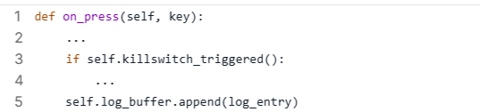

**Encrypting and Decrypting Logs:**

* Uses Fernet symmetric encryption for securing logs.



**Data Exfiltration:**

* Sends logs to a specified endpoint.
* Handles errors and retries.

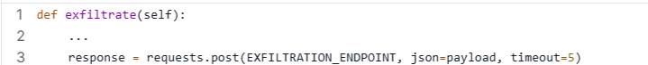

**Ethical Implications:**

* Keyloggers can be used for malicious purposes.
* Importance of consent and legal compliance.

**Security Measures:**

* Data encryption to protect user privacy.
* Implementation of a kill switch for user control.

Setup listner server for keystroke

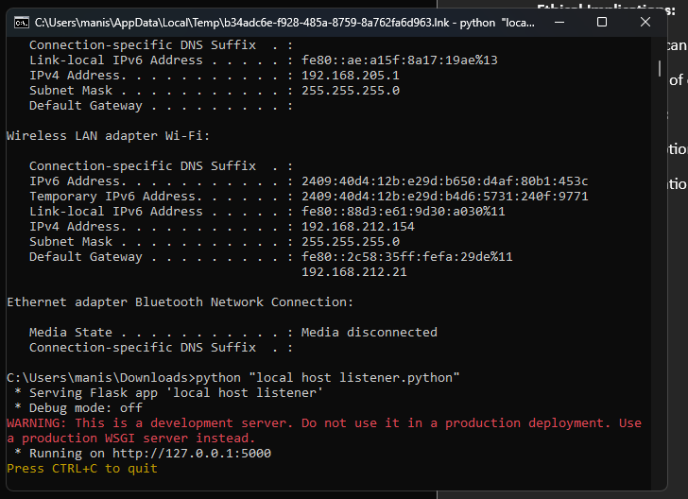

Main code File for keylogger

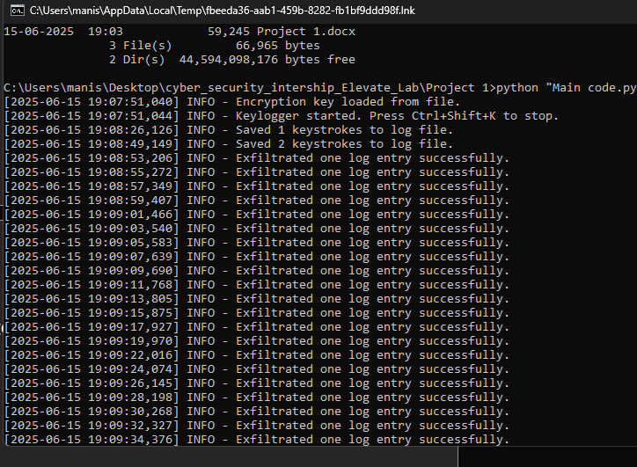

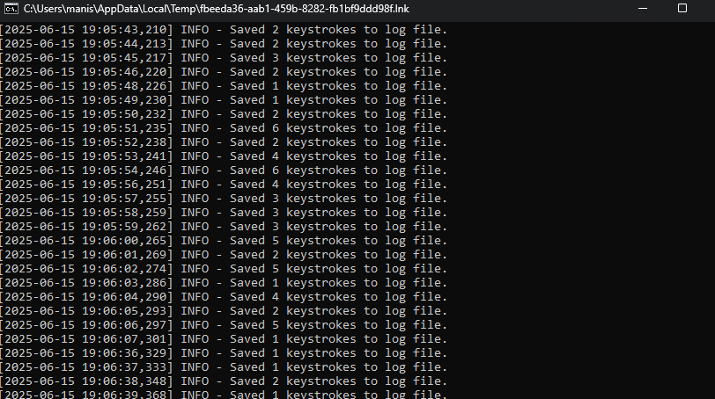

Final Demonstrations of project

